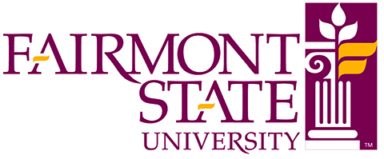
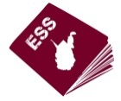
Earth and Space Science Passport Commitment Form

Funded by the West Virginia Math Science Partnership (MSP) Program, Earth and Space Science Passport (ESS Passport) is designed to engage teachers in professional development activities to enhance their understanding of ESS content and provide assistance in implementing the WV Next Generation Earth Science Standards. Designed to address the lack of certified ESS teachers, this professional development program targets middle and high school ESS teachers and provides pathways to enhance ESS instruction and certification.

To be completed by ESS Passport applicant To be completed by your principal:

ESS Passport expects you to:
- participate fully in year 1 activities:
- 2 week summer workshop at NRAO Green Bank (June19-July 2, 2016)
- After school monthly support webchats (second Monday of every month)
- fall WVSTA conference (October 27-29),
- spring geology field trip (March TBA)
- one day year-end feedback meeting (May TBA)
- participate fully in year 2 activities:
- one week summer workshop at Fairmont State University (June 31-Aug 4, 2017)
- after school monthly support training via webchats (second Monday of every month)
- year-end feedback meeting (May TBA)
- commit to working with a team to develop and share ESS lessons which address WV NxGen standards
- provide ESS Passport evaluators and researchers with feedback and respond to evaluation and research surveys

I will participate in the program through June2018
and I agree to the above list of expectations.
Printed Name Signature Date

Name of Principal Title Institution Address City State Zip Phone Email
Please submit to Deb Hemler
1201 Locust Avenue Fairmont, WV 26554, www.esspassport.org,
or email: esspassport@gmail.com
I hereby certify that
Applicant’s name
will be teaching Earth and space science content in the coming school year and is authorized by my institution to participate in the school year activities listed to the left. I understand that while he/she is fulfilling these school year expectations, I will need to grant release time (year 1- 4 days, year 2- 1 day) but understand that the school can invoice Fairmont State at a rate of $100/day to offset the cost of a substitute teacher. I will consider reimbursing the applicant the cost of the Earth & Space Science Praxis exam ($120) should he/she pass and gain ESS certification.

My institution agrees that ESS Passport is not liable for any actions of the applicant that may cause harm or liability to ESS Passport.

Principal’s Signature:

Date

