Mission Patch Design Competition

Up, Up, and Away!
Background
The West Virginia National Eclipse Ballooning Project (WV NEBP) team, in collaboration with the Space Grant programs around the country, we are participating in NASA’s nationwide ballooning project that will occur during the upcoming solar eclipses in 2023 and 2024. Students and educators around the state will work together to design, develop, test, and deploy high-altitude balloons that will fly along the ecliptic paths during each solar eclipse.
Mission Objectives
This mission aims to engineer two high-altitude balloons that can be sent into the atmosphere during the annular and total eclipses occurring over the next 18 months. These balloons will carry a variety of scientific payloads and will live stream the solar eclipses to be published on NASA websites and NASA TV. The annular eclipse will occur on October 14, 2023, while the total eclipse will occur on April 8, 2024.
An additional goal of this mission is to generate school and community involvement through lessons and outreach programs.
Mission Patch Design Challenge
Every NASA mission is only complete with a mission patch! From the earliest days of spaceflight, astronauts have had logos created that represented their mission. As such, those logos were then embroidered into mission patches to be sewn onto flight suits, turned into stickers to be handed out to the public, and posters created that represented the NASA mission. For example, consider Figure 1, which is the Apollo 11 mission logo. The graphic represents the American eagle, symbolic of the United States, that was about to land on the Moon. In its talons, an olive branch indicating the crew “came in peace for all mankind.”
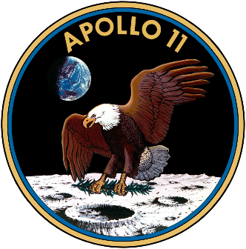
Figure 1. Apollo 11 Mission Logo
We are providing West Virginia students the opportunity to submit their creative design ideas to WV NEBP for a chance to win prizes and use them as the formal NASA logo for the high-altitude balloon missions. This is an excellent way for students to get involved in this exciting project and learn more about the science behind eclipses.

What to Submit:
West Virginia students should design a circular mission logo for the Eclipse Ballooning Project. Designs can be hand-drawn or virtually made, and hand-drawn photos should be scanned or photographed to be submitted.
Submission Process:
Submit all designs to wvspacegrant@gmail.com Please include your name, school, and grade with your submission.
Prizes:
- K-6th: one overall award for $50
- 7-12th: one overall award for $75
- Higher Education: one overall award for $100
Selected designs will be used as formal NASA mission logos and appear on all patches, stickers, and posters. The WV NEBP will request a non-exclusive unlimited license to use the design.
Mission Patch Requirements:
- The student’s name, grade and school must be included with the submitted design.
- All designs submitted will not be returned.
- You must have the year (2023-2024) in your design
- The design must be your original work; you may not copy or trace another.
- All entries must come with the release forms signed by the student(s) and parent(s)/ guardian.
- Write a one-paragraph description of the elements of your design and why you used them.
- The Mission Patch can be black & white or full color, with a limit of 9 colors.

Mission Patch Constraints (limitations)
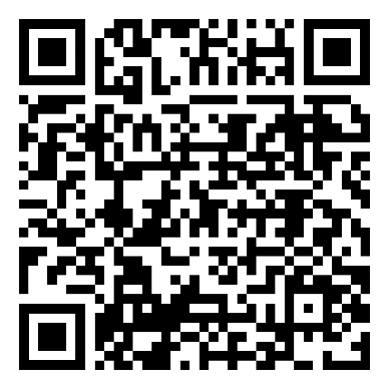
- The Mission Patch must be a piece of paper NO LARGER than 3.5-inch x 3.5-inch (89mmx89mm) and
- The mission patch design cannot include multiple layers of paper glued or taped on top of one another.
- Keep the design simple and clear.
- You may include words but keep it short.
- You may use computer graphic design programs to create your work; submit a full-color hard copy of your entry.
- Due Date: Submissions are to be received by the WV NEBP (wvspacegrant@gmail.com) team by COB May 1, 2023.

