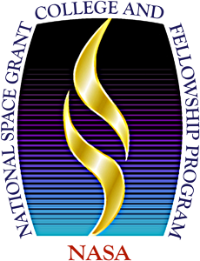

West Virginia University (Lead)
Bethany College
Bluefield State University
Community and Technical College System of WV
Fairmont State University
Glenville State University
Green Bank Observatory
Marshall University
NASA Katherine Johnson Independent Verification & Validation Facility
Polyhedron Learning Media, Inc.
Shepherd University
West Liberty University
WV High Technology Foundation
West Virginia State University
WVU Institute of Technology
West Virginia Wesleyan College
Wheeling University

For additional information on our programs,


NASA WEST VIRGINIA SPACE GRANT CONSORTIUM
Melanie Page, PhD, Director
Candy Cordwell, MSc, Assistant Director
Kisstaman Epps, MA, Program Coordinator
Alyssa George, Admin Assistant
West Virginia University
P.O. Box 6070, Morgantown, WV 26506-6070
(304) 293-4099│ wvspacegrant.org
BOARD OF DIRECTORS
Bethany College
Dr. Lisa Reilly, Chair, Department of Physical and Computational Sciences

Bluefield State College
Dr. Ted A. Lewis, Provost & VP of Academic and Student Affairs

Columbus Technologies and Services, Inc.
Dr. Mina Samii, Executive Vice President of Aerospace

Community and Technical College System of WV
Dr. Chris Treadway, Vice Chancellor, WV Council for Community & Technical College Education

Director Emeritus
Dr. Majid Jaridi

Fairmont State University
Dr. Steven Roof, Dean, College of Science & Technology

Glenville State University
Ms. Leslie Mason, Senior Director of Grants and Compliance

Green Bank Observatory
Dr. Karen O’Neil, Director

Marshall University
Dr. John M. Maher, Vice President for Research

NASA IV&V Facility
Ms. Joelle Spagnuolo-Loretta, NASA IV&V Office Lead

Polyhedron Learning Media, Inc.
Dr. Jeanne Finstein, President and Director of Development

Shepherd University
Dr. Reza Mirdamadi, Chair of Computer Science, Mathematics, & Engineering Department

West Liberty University
Dr. Karen Kettler, Dean, College of Sciences

WV High Technology Foundation
Mr. James L. Estep, President and CEO

West Virginia State University
Dr. Naveed Zaman, Dean, College Natural Sciences and Mathematics

West Virginia Institute of Technology
Dr. Tamara Floyd Smith, Dean, Leonard C. College of Engineering and Sciences

West Virginia University
Dr. Duncan Lorimer, Associate Dean for Research, Eberly College of Arts and Sciences

WV Wesleyan College
Dr. Joseph Wiest, Professor of Physics & Engineering

Wheeling University
Dr. Neetika Sharma, Chair, Assistant Professor of Physics and Engineering

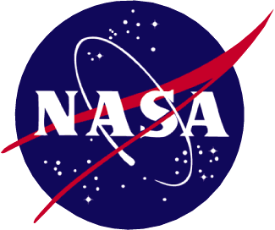

Dedicated to building research infrastructure and the promotion of Science, Technology,
Engineering and Math (STEM) education in West Virginia

WVSpaceGrant.org

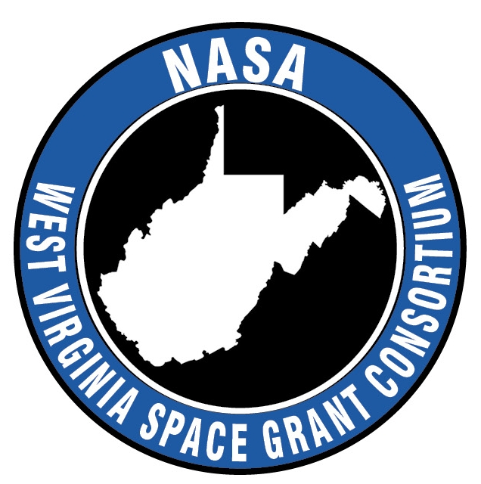

The West Virginia Space Grant Consortium (WVSGC or “the Consortium”) is a National Aeronautics and Space Administration (NASA) sponsored organization established in August 1991. It is comprised of 13 West Virginia (WV) academic institutions and five corporate and scientific partners. It is dedicated to building research infrastructure and promoting Science, Technology, Engineering and Math (STEM) education in WV. The Consortium’s programs focus on research, collaborations with high-technology industries, student fellowships as well as K-12, and public outreach programs. This is consistent with the strategic vision for the state’s participation in the nation’s current and future endeavors in science and technology.
The Consortium is housed in the Benjamin M. Statler College of Engineering and Mineral Resources on the Evansdale Campus of West Virginia University (WVU) in Morgantown, WV.

An important component of WVSGC’s mission is to help build research infrastructure at its member institutions. The Consortium is pleased to offer research grants for the four programs listed below. Each program is open to competition by faculty from all the Consortium’s affiliates and each award category is judged separately based on published criteria.
Research Initiation Grants
Faculty members from all academic affiliates of the Consortium may apply for research initiation grants. The objective of this program is to stimulate NASA sponsored research at WV colleges and universities. These grants will help faculty members build long-term relationships with NASA researchers, as awardees pursue research in areas of scientific interest to NASA. Projects will be reviewed by NASA personnel for technical merit and will be awarded by the Consortium based on the availability of funds.
Research Enhancement Awards
Each academic affiliate of the WVSGC receives NASA funds to be matched by non-federal sources provided by the institution. Competitive awards are made to research projects that have the maximum potential for enhancing the research capability of the faculty and the promise of long-term cooperation with NASA field centers. NASA Committees set up at each academic affiliate establish the criteria for competition and make the awards.
College Course Development Program
This program funds projects to develop new and innovative courses at academic affiliates of the Consortium. Applicants are required to present a clear and feasible plan for designing and offering a new course in STEM fields.
Joint University–Industry Research Program
WVSGC supports research within the growing high-technology sector of the WV economy. The goal of this program is to foster and cultivate collaborative research between researchers at WVSGC academic affiliates, aerospace-related and other high-technology companies in the state.
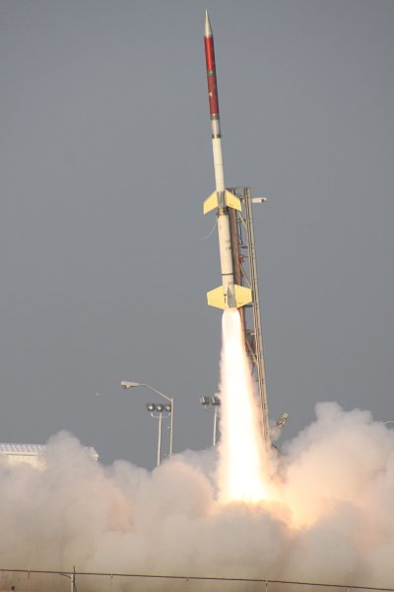
RockSat Program
WVSGC sponsors higher education projects
that benefit the Consortium students directly and
prepare them for a STEM career

The WVSGC sponsors three different fellowships: the NASA Graduate Research Fellowship; the NASA Undergraduate Research Fellowship; and the NASA Undergraduate Space Grant Scholarship. All three provide students with opportunities to work directly with Consortium faculty members in a mentor relationship, as well as the opportunity to participate in NASA and/or Consortium activities. Recipients of these fellowships must be U.S. citizens.
The NASA Graduate Research Fellowship is designed to provide graduate students in STEM fields with the opportunity to pursue graduate level education and work on a research project. The goal is for the students to deepen their education and research experience, and to participate directly in NASA activities.
The NASA Undergraduate Research Fellowship was established to encourage some of WV’s brightest students to pursue a college education in STEM fields in their home state, and to provide them with an opportunity to develop connections with NASA activities early in their careers. Criteria for selection include the student’s academic record, extracurricular achievements, soundness and technical merit of the proposed research.
The NASA Undergraduate Research Scholarships offers support to students pursuing degrees in STEM fields and gives them an opportunity to participate in a variety of Consortium activities. The amount awarded varies for each institution. Space Grant Scholars are selected by NASA Committees at each academic affiliate.

K-12 Professional & Curriculum Development Program
One of the goals of the Consortium is to enhance the interests and enthusiasm of students in science, engineering, and space-related disciplines. To achieve this goal, the Consortium invites organizations and qualified individuals to design and implement outreach projects in the science area for each academic year. Projects could include classroom-based activities or professional development opportunities for teachers. Awards are made for a one-year period and criteria for selection of these projects, among others, will include: the long-term viability of the activity, the depth and breadth of impact on student, and the degree of adherence to the state's STEM standards and reform initiatives. Inclusion of plans and special effort to bring in minorities and women to actively participate and benefit from the project will be considered a plus and is highly encouraged.
Extension and Public Outreach Program
The Consortium’s vision is to involve the public in the excitement of scientific discovery, emphasizing the importance of STEM education and bringing the Vision for Space Exploration to the grassroots. This program provides funds to develop new and innovative outreach programs in WV which in turn promote STEM literacy and awareness of NASA’s mission. Examples of such applications include conferences that advance the understanding, education, development, and utilization of space; seminars or training sessions that encourage interdisciplinary training and research in aerospace-related fields; or informal education activities for the general public or student groups (e.g., scout groups or astronomy clubs).

